**THE FISTRAL BEACH**

**Fistral Beach** is in **Fistral Bay** on the [north coast](https://en.wikipedia.org/wiki/Atlantic_coast_of_Cornwall) of [Cornwall](https://en.wikipedia.org/wiki/Cornwall), England, United Kingdom. It is situated half a mile west of [Newquay](https://en.wikipedia.org/wiki/Newquay" \o "Newquay) at [grid reference](https://en.wikipedia.org/wiki/Ordnance_Survey_National_Grid) [SW 797 620](https://geohack.toolforge.org/geohack.php?pagename=Fistral_Beach&params=50.416377_N_5.102351_W_region:GB_scale:25000).

The name "Fistral" is recorded as *Fistal* in 1813, coming from the [Cornish](https://en.wikipedia.org/wiki/Cornish_language) *bystel* meaning "foul water, bile or gall" (compare Welsh *bustl*) probably in reference to the waves making it an unsuitable landing site.

The straight sandy beach faces west-northwest onto the [Atlantic](https://en.wikipedia.org/wiki/Atlantic_Ocean) and is approximately 750 metres (2,460 ft) long. It is backed by steep [sand dunes](https://en.wikipedia.org/wiki/Sand_dunes) and is overlooked by the [*Headland Hotel*](https://en.wikipedia.org/wiki/Headland_Hotel)

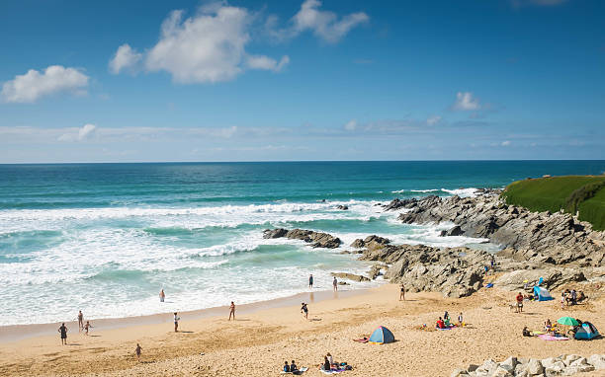

The beach is the venue for major international surfing competitions and a competition suite for judges and competitors has been built at North Fistral along with a surf museum.

The [British Surfing Association](https://en.wikipedia.org/w/index.php?title=British_Surfing_Association&action=edit&redlink=1), [Newquay Surf Life Saving Club](https://en.wikipedia.org/w/index.php?title=Newquay_Surf_Life_Saving_Club&action=edit&redlink=1) and the [Newquay Boardrider Club](https://en.wikipedia.org/w/index.php?title=Newquay_Boardrider_Club&action=edit&redlink=1) are all based at Fistral Beach.